

**2019 MASTERs Conference**

**23075 IoT6**

**Simplifying TCP/IP Applications with MPLAB® Harmony**

**Hands-On**

**Lab Manual**

***Instructors:***

***Martin Ruppert***

***Raji Shanmugasundaram***

***Niklas Larsson***

*Microchip Technology Inc.*

Table of Contents

Introduction 3

Hardware Requirements 4

Software Requirements 5

How to connect the USB and the CAT5 Network cable to the board 6

Lab 1 7

Overview 7

Lab Procedure 8

Lab 2 28

Overview 28

Lab Procedure 32

Lab 3 50

Overview 50

Lab Procedure 53

MPLAB® Harmony TCP/IP Stack 56

TCP Module API Function List 56

UDP Module API Function List 57

Harmony TCP/IP API Subset For all Lab’s 58

TCP Socket Management Functions 58

UDP Socket Management Functions 62

66











# Introduction

This Lab Manual provides the step by step procedure to complete two labs in the MASTERs 23075 IoT6 Class.   
  
If you don’t know how TCP/IP works but you have to add network connectivity to your product, this is the right class for you. We will teach you the basics of TCP/IP, how the client-server model works, what ports and sockets are and how applications use them to create TCP/IP connections. The class will also teach you the fundamentals of network analysis with the well-known tool Wireshark. The hands-on part of the class utilizes Microchip's 32-bit MCUs with MPLAB® Harmony. You can learn the architecture and the fundamentals of the Harmony TCP/IP stack to interface your TCP/IP application with some common stack APIs. To make your life easier, the FreeRTOS™ task schedular is used to simplify your application programming.

In Lab 1 we will open a TCP project, do some stack re-configuration and a connectivity check and in Lab 2 we will show an Application integration for local access, using the example of a Vending machine. Finally in Lab 3 we will make an Application integration for external access, using the example of a Weather Service.

# Hardware Requirements

The following hardware is required:

* **SAM E70 Xpained Ultra** (Microchip Part Number: DM320113)
  + <https://www.microchip.com/DevelopmentTools/ProductDetails/PartNO/DM320113>   
    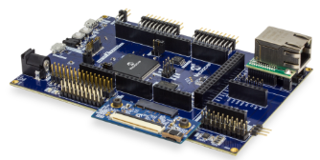
* OLED1 Xplained Pro extension kit (Microchip Part Number: ATOLED1-XPRO)
  + <https://www.microchip.com/Developmenttools/ProductDetails/ATOLED1-XPRO>   
    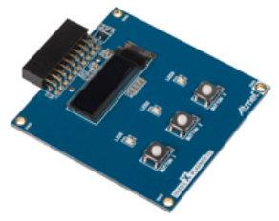
* **Cat 5 Ethernet Patch Cable**
* **USB Male A to USB Male B Micro Cable**

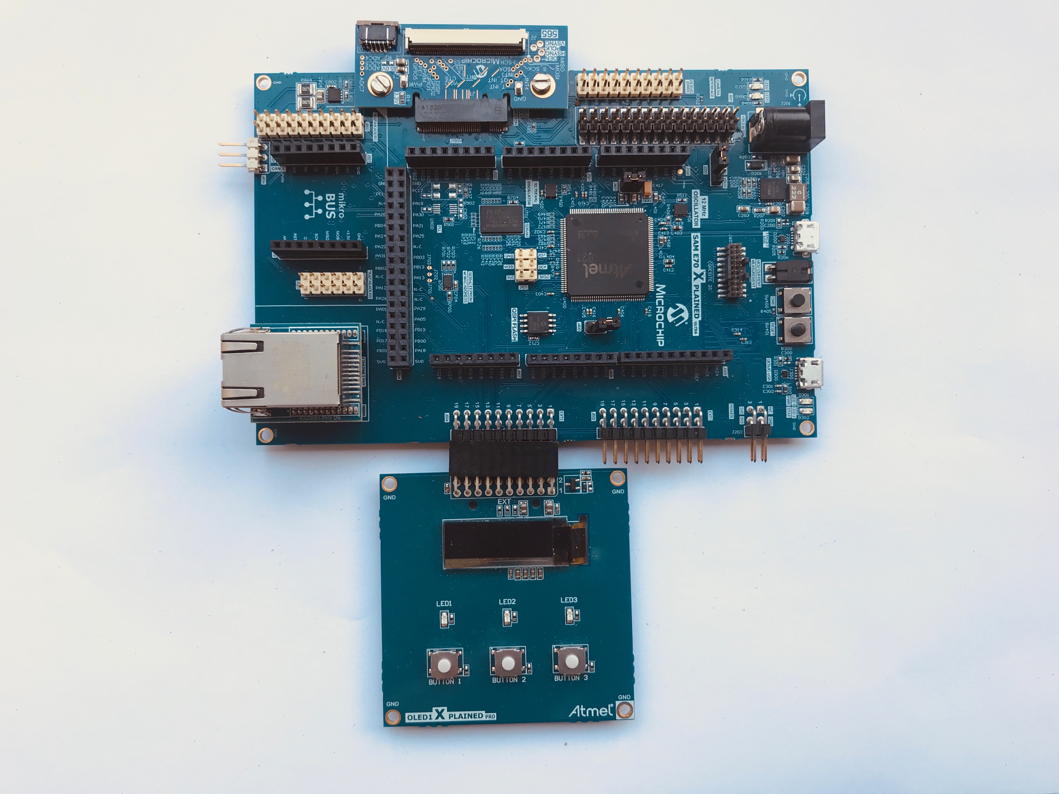

# Software Requirements

The following software is required:

* **Microchip MPLAB X IDE v5.20**
  + <http://www.microchip.com/mplab>
* **Microchip MPLAB XC32 Compiler v2.15**
  + <http://www.microchip.com/mplab/compilers>
* **Microchip MPLAB Harmony 3**
  + <http://www.microchip.com/mplab/mplab-harmony>
* **Microchip MPLAB Harmony Configuration (MHC) Tool Plugin v3.3.0.1**
* **Tera Term v4.95**

The Lab1, Lab2 and Lab3 class expects a Harmony 3 with the following subset of Versions (Tags)  
To make it more easy in the class for the attendees, the folder C:/MASTERs/23075 already contains this H3 Checkout 

In the (optional) case a standard Harmony 3 installation is used, in the MHC configuration the **csp** v3.2.1 and **core** v3.2.1 must be selected. This can be done by clicking on the sub module and select in the drop down menu, the above mentioned version.   
The following checkout could take several minutes. The checkout is only local, no external Github access will be used. 

# How to connect the USB and the CAT5 Network cable to the board

* Ensure the Erase jumper is open
* Open the J805 jumper





# Lab 1

## Overview

Lab 1 will show you how to open an existing TCP/IP MPLAB Harmony 3 Project and using the MPLAB Harmony Configuration (MHC) Tool. The project will incorporate basic TCP/IP functionality to allow the SAM E70 Xplained Ultra to connect to an Ethernet Network, along with a simple application to flash a “Heartbeat” LED every 500ms. Once the project is generated and programmed onto the development kit, you will use a number of techniques to validate that the PIC is connected to a network and determine its IP Address. The concepts that will be covered in this lab include:

* Open a SAM E70 MPLAB X Project
* Configuring the MPLAB Harmony path
* Configuring the TCP/IP Stack options, including:
  + Network Configuration of the Host Name
  + TCP/IP Services including Dynamic Host Configuration Protocol Client, ICMPv4 Server (for Ping testing) & Announce Discovery Tool
  + Bandwidth testing with “iperf”
* Configuring the Harmony Console and Command Service for monitoring and control of the TCP/IP stack via a Terminal Client running on a USB CDC Interface (Emulated RS232 COM Port).

Toggling the IO Pin that drives USER_LED0 on the SAM E70 Xplained UltraSAM E70 Xplained Ultra

* Using the Windows Command Line Ping Tool and the Microchip TCP/IP Discovery tools to test connectivity of your SAM E70 Xplained UltraSAM E70 Xplained Ultra on the network
* Use the Console and Command System to get help on available TCPIP Commands and execute a command to get information about the network configuration.

## Lab Procedure

Starting MPLAB X IDE

* 1. Start MPLAB X IDE by double clicking on the MPLAB X IDE v5.20 icon found on the Windows desktop.

|  |
| --- |
|  |
|  |

Project Load, modify with MHC, Generate, build and run

1. Open Project by choosing File⮞Open Project… from the main menu and select lab1 project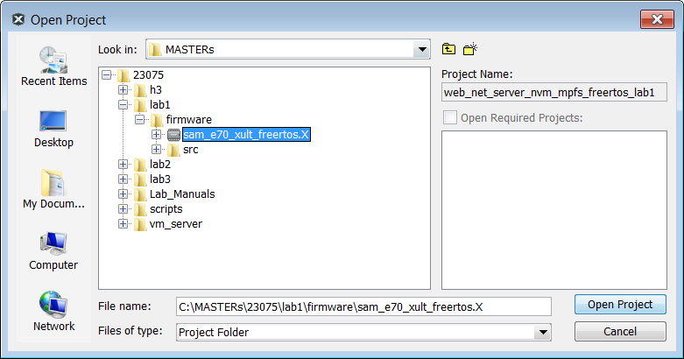
2. Open Project Properties by choosing
   1. File⮞Project Properties from the main menu
   2. Or select with a right click the project node in the project windows and select at the bottom  
      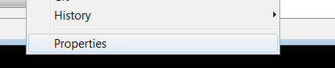
   3. Or select the toolbox in the Dashboard  
      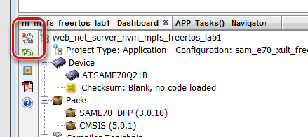



1. Select the XC32 Compiler v2.15
2. Select the SAME70 Xplained by clicking on the SN: Number

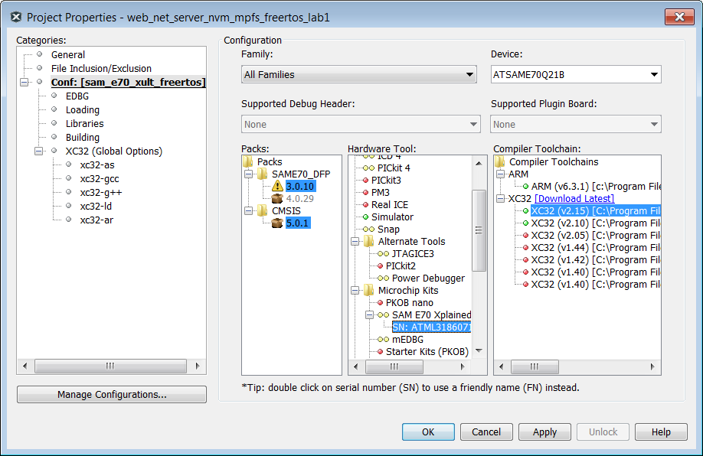

1. Select from the Tools Menu the Harmony 3 Configurator  
   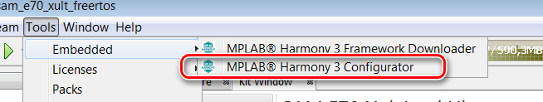
2. Ensure the H3 Path is set to “C:\MASTERs\23075\h3\”  
   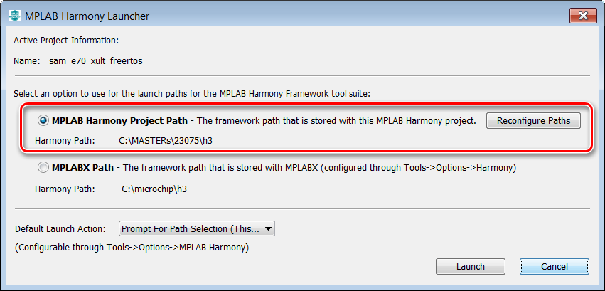
3. Select “Launch”  
   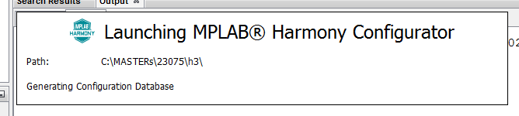  
   The first time the MHC is started, it can take up to 2 Minutes before the Configuration Database is prepared
4. In the next window the H3 parts and their used Version Numbers are displayed  
   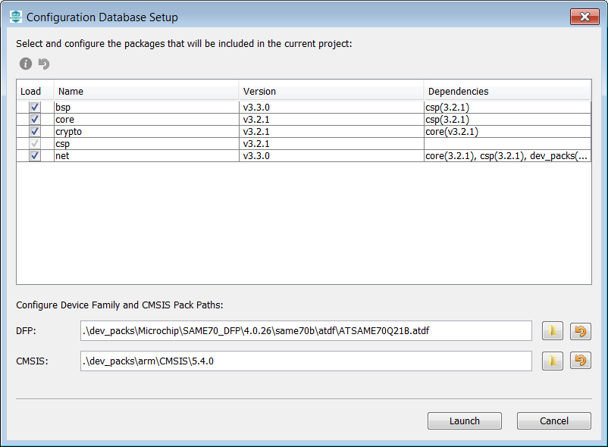  
   Click on “Launch”
5. Open the saved state file  
   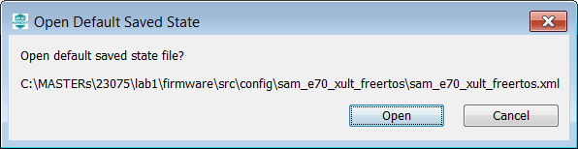
6. The MHC is up and running  
   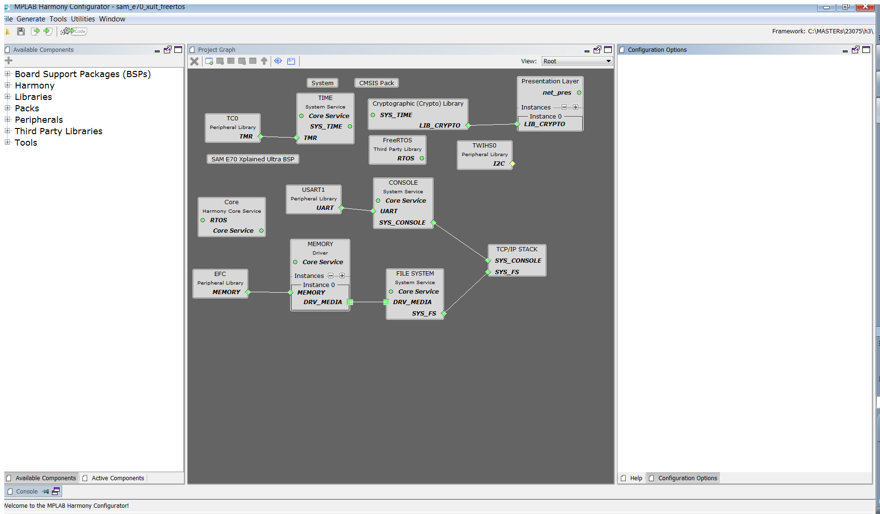
7. Select Active Components (left below)  
   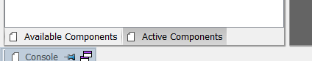
8. Select the Instance 0 in Active Components  
   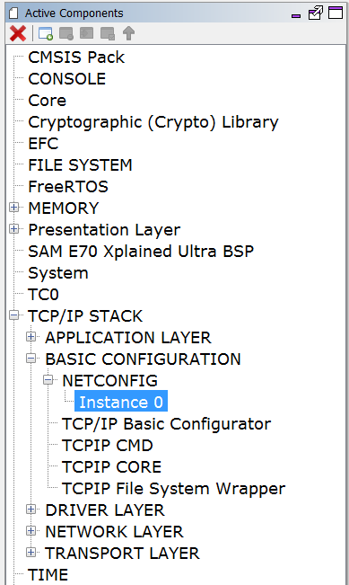
9. And change in the Configuration Options (on the right side) the Host Name to something meaningful for you.   
   The Host name can be identified in the Network.  
   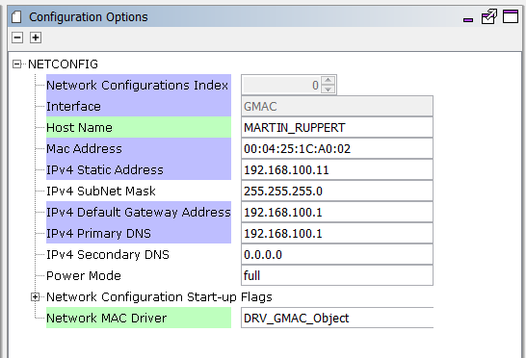
10. Select “TCP/IP Application Layer Configuration” in Active Components   
    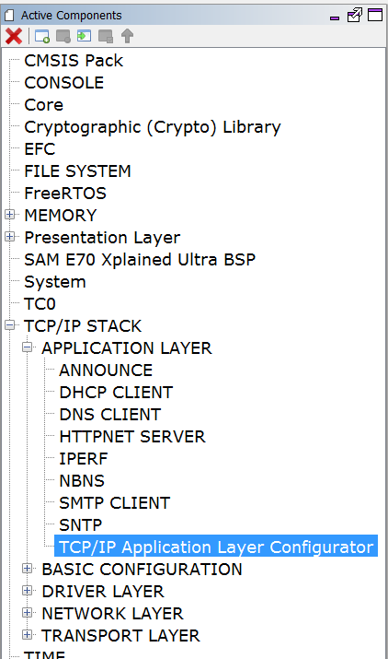
11. Ensure that ANNOUNCE and IPERF are selected  
    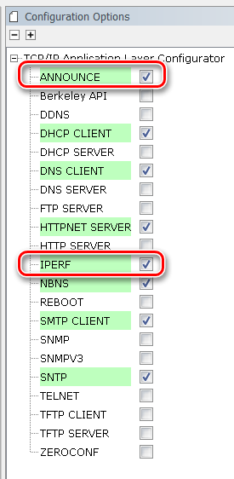
12. Select ICMPv4 in the Active Components  
    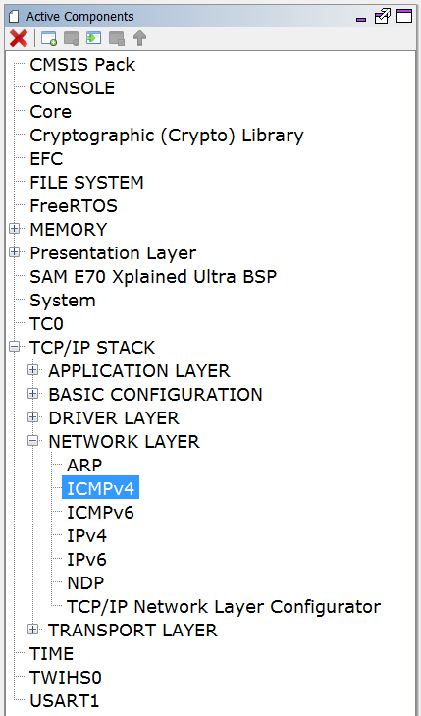
13. And ensure that the “Use ICMPv4 Client” is selected  
    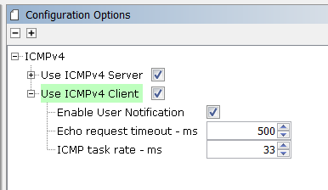
14. Select “Code” (Generate Code)  
    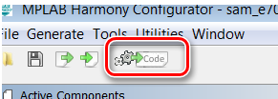
15. Select Don’t Save  
    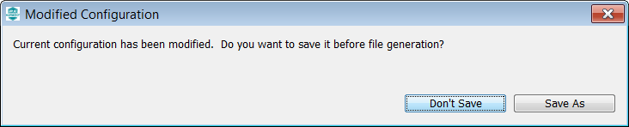
16. Select Generate  
    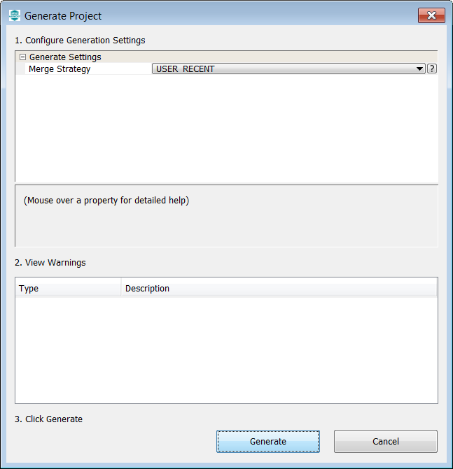
17. Some Files will be changed and the MHC is asking in a “diff” window, if the changes should be taken over.  
    Accept all changes in the file by clicking on the Arrow in the middle above.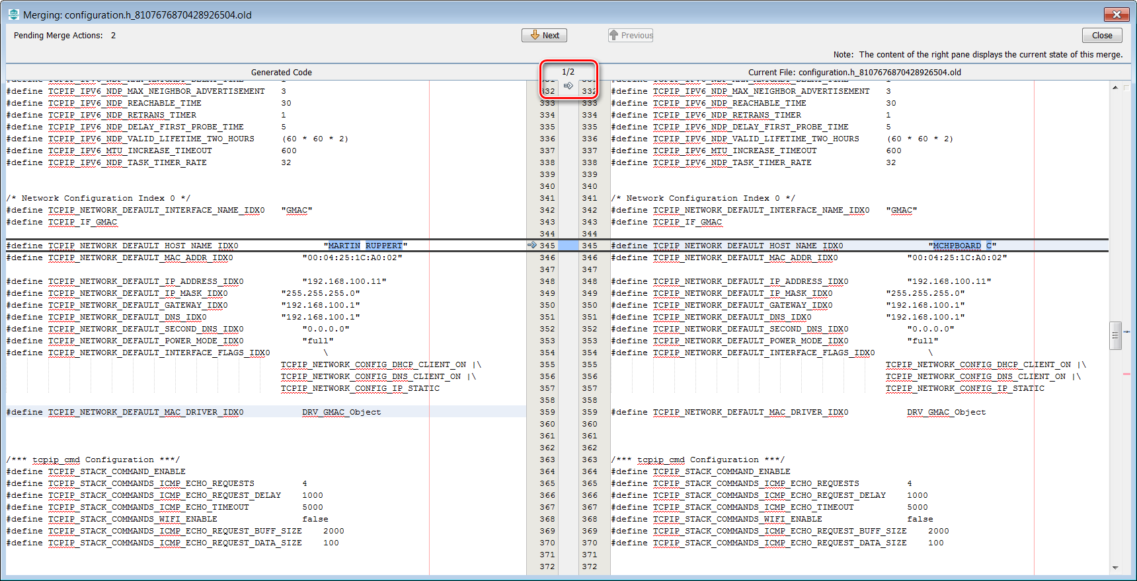
18. Then click on close in the upper right corner  
    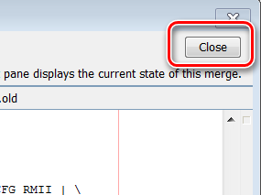
19. Same for the next 2 diff windows  
    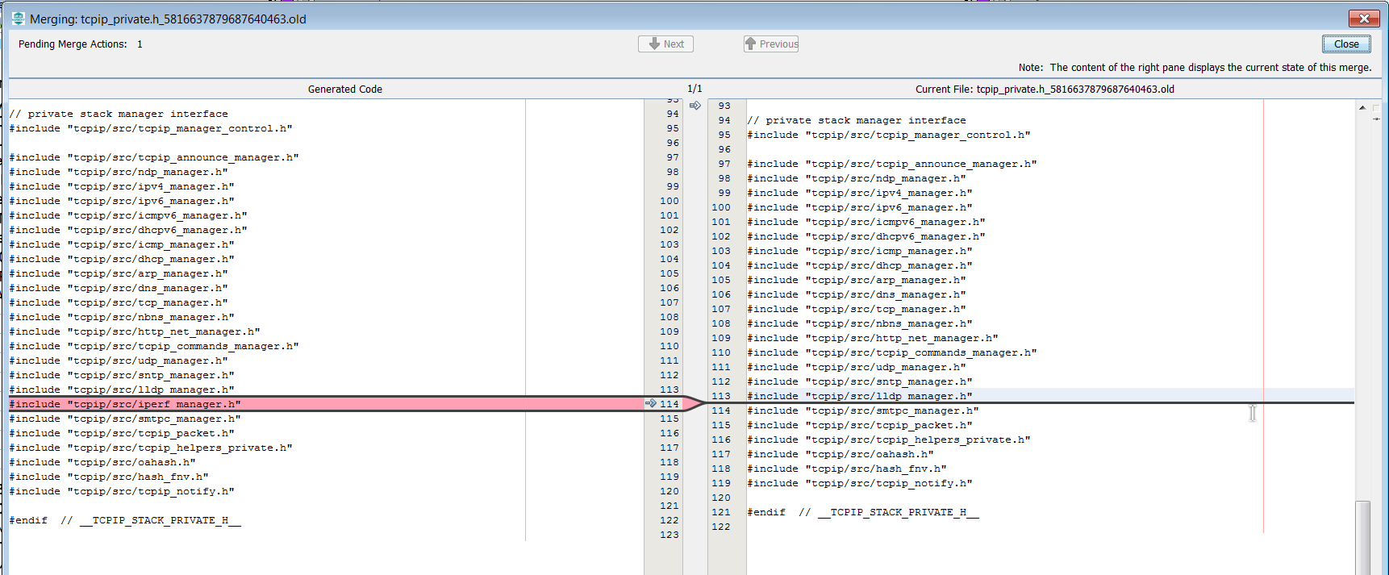
20. The whole process is displayed with a progress bar  
    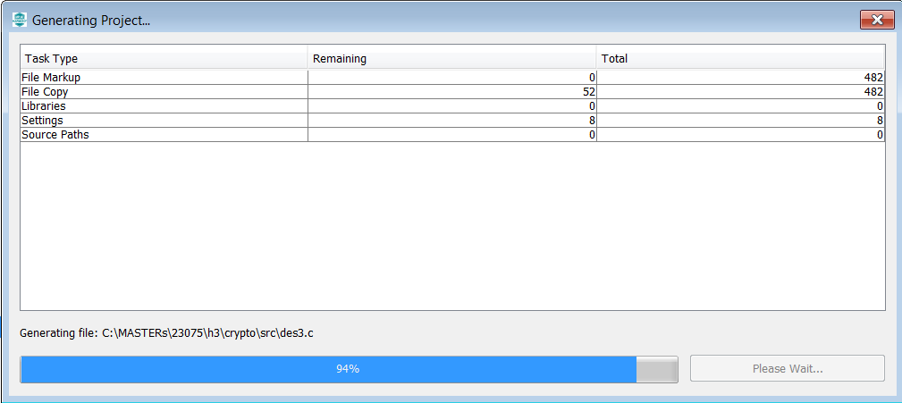
21. Back again in the main window of MPLABX, click on the “Make and Program Device” button  
    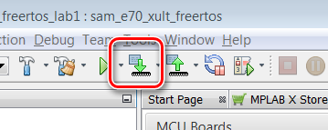
22. After successful build, the SAME70 is programmed automatically   
    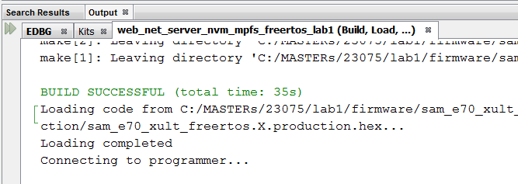
23. The programming take about 30 seconds with on Board Debugger Check whether the USER_LED0 Activity is Blinking  
      
      
      
      
    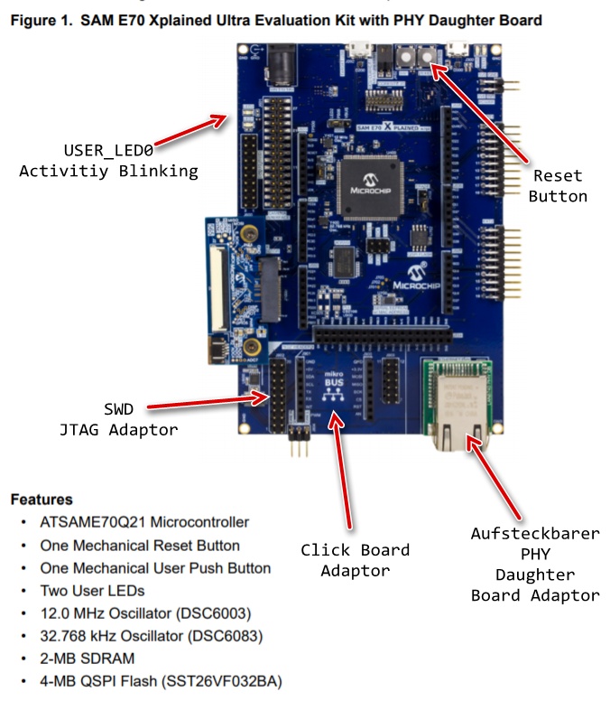
24. Open Terra Term Terminal Program  and select under Setup->Serial Port the COM Port and the Baudrate 115200 (in this case a COM96, but could be a different COM Port number in your case).  
      
    The press the Reset Button of the Board and let the Firmware restart. You should see the start message with the Lab name and the build timestamp at first, followed by the MAC Address from EEPROM.
25. After some small time, the IP Address should be change from 0.0.0.0 to a valid address  
    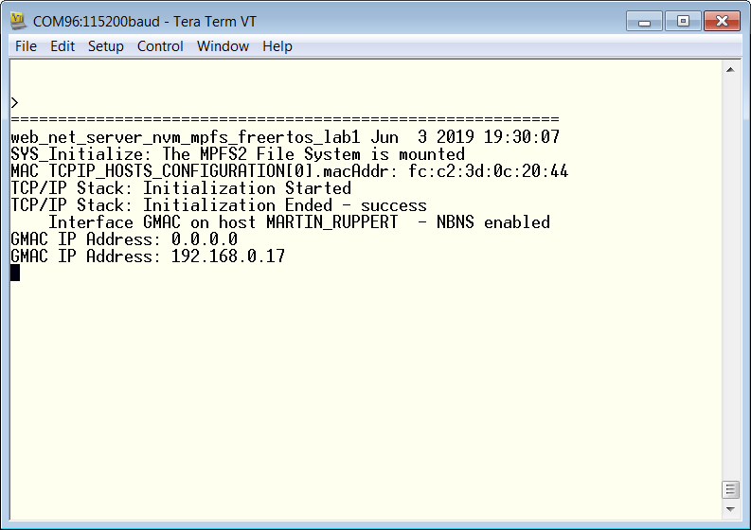
26. To check the basic information about the network enter the netinfo command and press Enter.

|  |
| --- |
|  |

1. A help shows the available commands  
   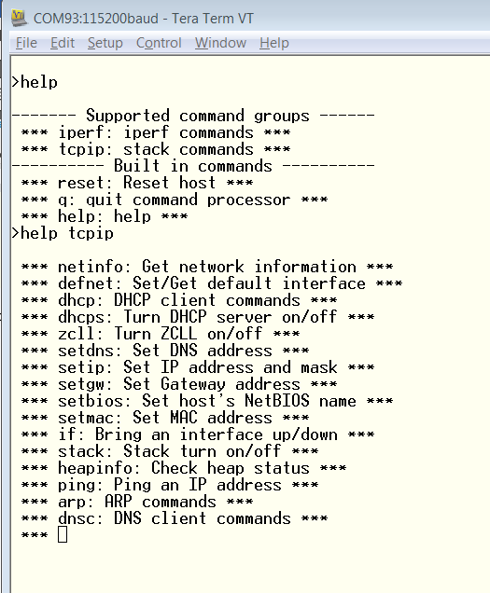

|  |
| --- |
|  |

|  |
| --- |
|  |

1. As a first simple test you can ping an external Server or anything else you like (Maybe the board of your class neighbor?)  
   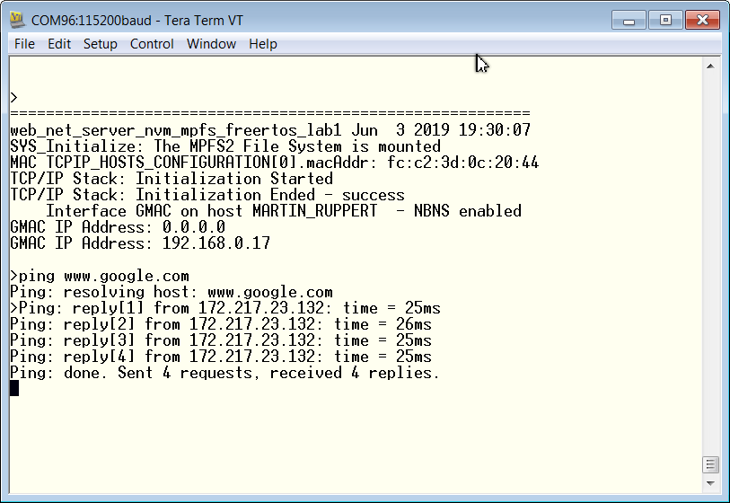
2. Select the **tcpip_discoverer** tool from   
   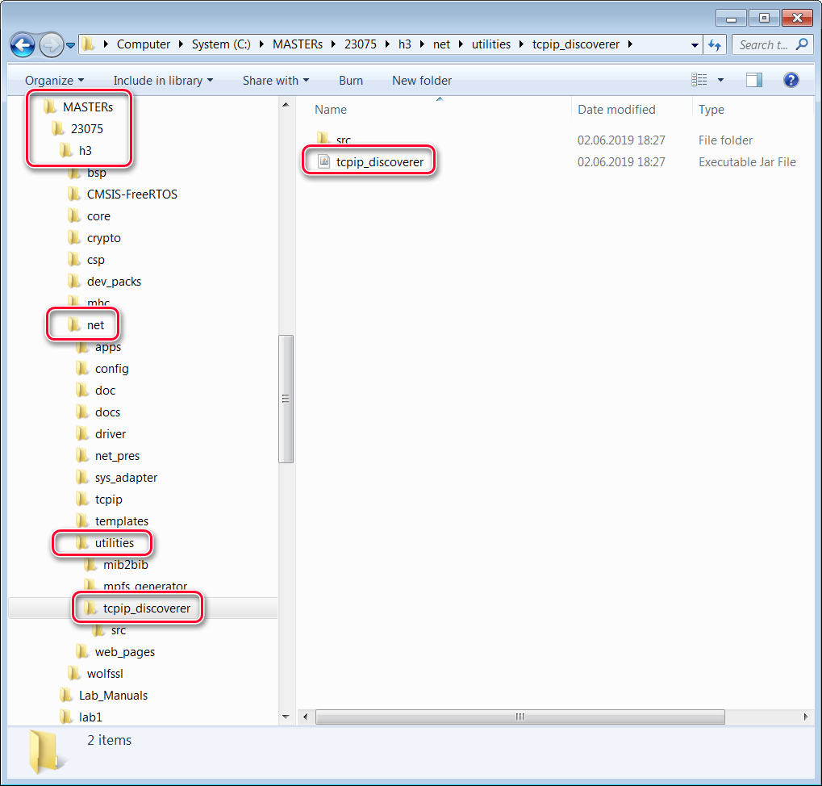
3. If Windows is asking for permissions allow the access  
   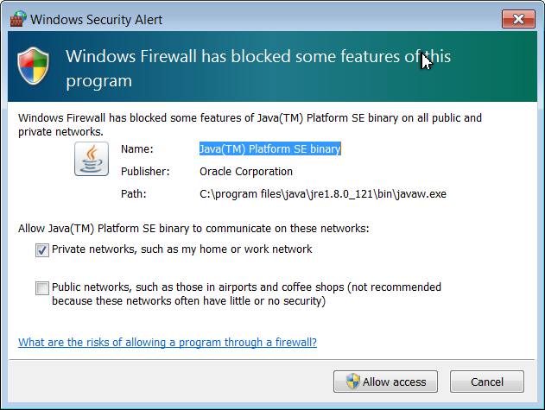
4. The TCP Discover should list all boards in the classroom. We have made this tool to help you to find your board in the network. The source codes of this tool (Java) are part of the H3.   
     
   You can identify your board by the Host Name that has select in an earlier step. The Host Name is also known to the DHCP server and is listed in their typical Web Interfaces as a connected device.   
   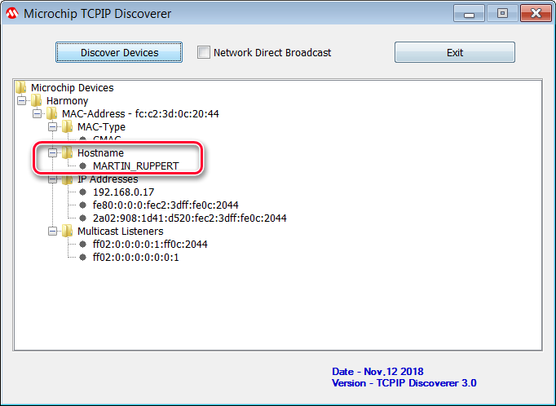  
     
   Press the Discover Devices button: The tool will send a UDP broadcast on port 30303, with the packet “Discovery, who is out there?” All H3 devices running the Announce service will respond to this broadcast, by sending a return broadcast on port 30303. The broadcast packet contains data on the type of interface used, the Host Name, MAC and IP Address. The Discover tool listens to all broadcasts on port 30303 and will show found devices under the Microchip Devices tree. You can identify your device by looking for the host name that you entered in MHC Setup process. The Microchip TCPIP Discoverer tool also shows the IP address for your board.
5. A double click on the **MAC-Address** line will put you in your default Internet Browser  
   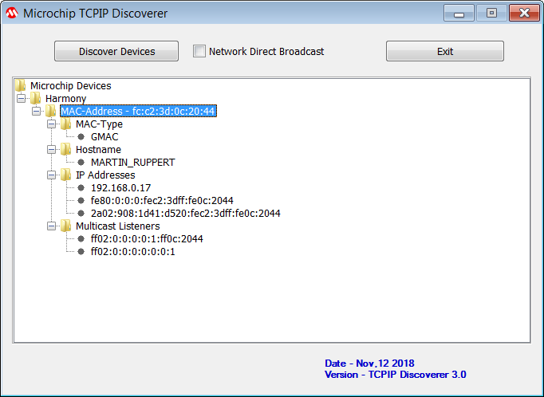







































































































































































































1. And the Webpage is displayed. Please take some time an play with the sub menus to find out the capabilities of or H3 Web Server  
   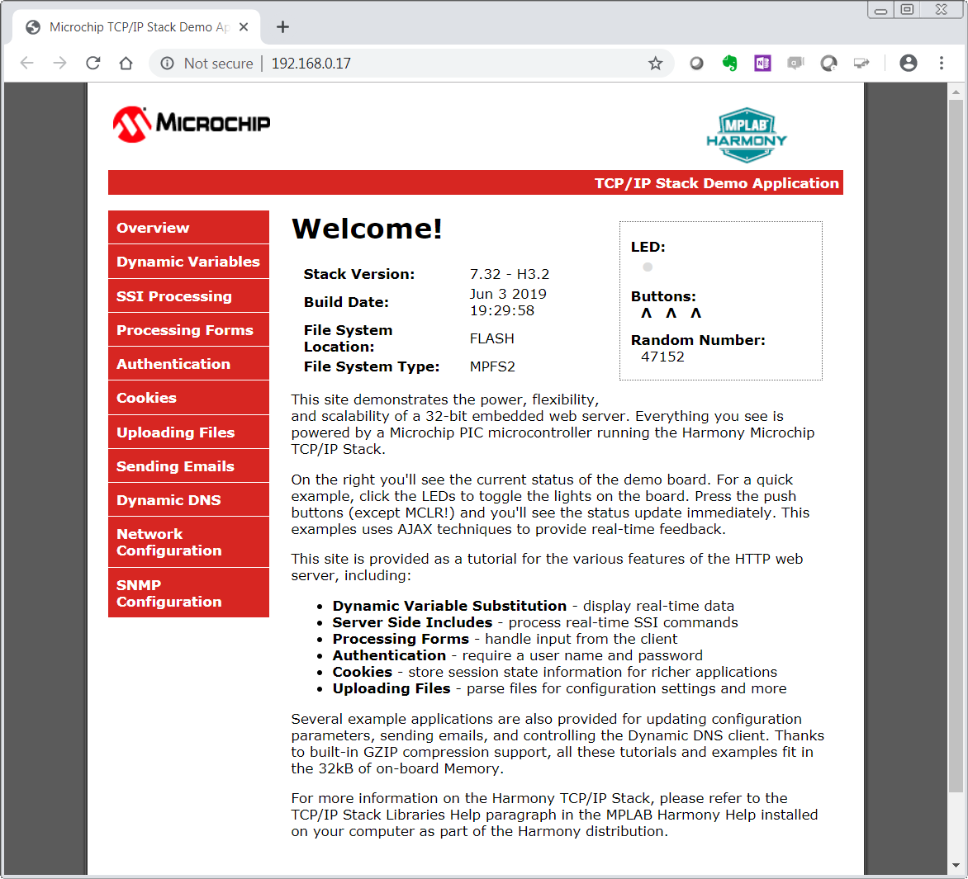Congratulations, you have completed Lab 1!











































































































































































































































































































# Lab 2

## Overview

You will be implementing an embedded network application to update and track status of an Vending Machine (VM).

The implementation is sectioned into two modules.

TASK 1:

E70 HTTP- SERVER

/Vending Machine -1

Ethernet Switch

PC – HTTP-Client (1)

E70 HTTP-SERVER /Vending Machine-(n)

PC- HTTP-Client (n)

The task is to interface the up/down and select buttons and an OLED of a Vending Machine to the HTTP-Server. The HTTP-Server keeps track of the items in the Vending Machine.

The HTTP- Client (PC-web page) talks to the HTTP- server and displays the status of the Vending Machine. The HTTP-Client also sends out an update request to the HTTP- server using Ethernet Interface.

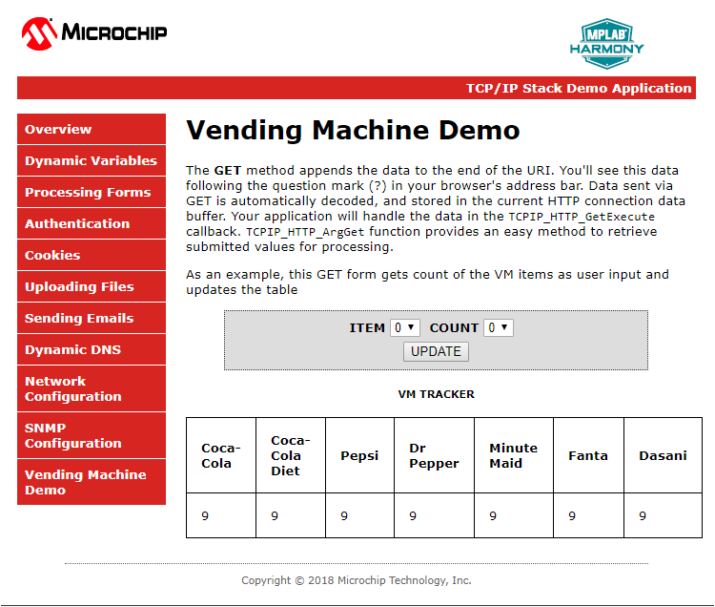

TASK 2:

The task is to make all the VMs in the class network to talk to a server. When a Bay of a VM is empty it sends out a message to a common server.

Ethernet Switch

E70 HTTP-SERVER / Vending Machine (1)

SERVER

E70 HTTP- SERVER / Vending Machine (n)

An example Message:

“Message: 1 from Martin: The Pepsi Bay is empty”

The Message number (1) and the Host name (Martin) together forms a unique Message and makes it easy to differentiate your message from other VMs on the network server and the number helps to find the recent ones.

Data Protocol

TASK1

GET /[VM.htm?ITEM=2&COUNT=5](http://10.13.33.91/VM.htm?ITEM=2&COUNT=5) HTTP/1.1

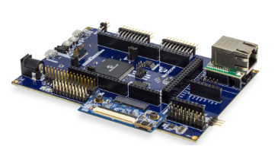

**TCP HTTP Port 80**

Sends the request “**GET /MY_Data.xml HTTP/1.1**” for every 500ms



PC HTTP-Client-1

**TCP HTTP Port 80**

HTTP/1.1 200 OK

Sends the MY_Data.xml file to update the web page with current data



PC -HTTP-Client-1

**TCP HTTP Port 80**

PC HTTP-Client-1



VM-1

|  |
| --- |
| VM-1 |

VM-1

TASK 2



**BAY Empty Message**

**BAY Empty Message**

**BAY Empty Message**

VM-1

CLASS SERVER

VM-2

VM-3

Application Implementation

The Vending Machine demo (Task 1 and 2) is implemented using “**SAM E70 Xplained Ultra Evaluation Kit** “and “**OLED1 Xplained Pro Extension Kit”.** The OLED Xplained prohas three buttons, LEDs and an OLED.

* The VM application uses Button 1(Down) and 2(UP) to scroll through the VM items and Button 3 to select an item from the Vending Machine.
* The LEDs above the button indicates a button press with a blink.
* The OLED is used to display the name and their corresponding number of the items in a Vending Machine.
* When select button(B3) is pressed the HTTP-Server will decrement the count of an item and updates the HTTP-Client(Web page)through ethernet interface.

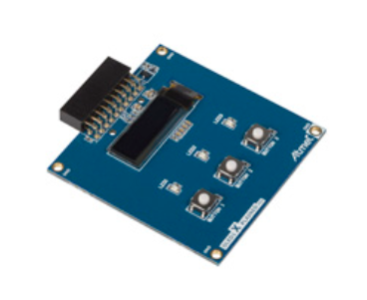

E70 WEB SERVER

/Vending Machine

|  |
| --- |
|  |
|  |
|  |
|  |
|  |

The Vending machine demo runs the below user applications in conjunction with MPLAB Harmony TCP/IP Stack:

* **OLED and Button Contoller** (MMI_Tasks): Manages the operation of the OLED display , Buttons and LEDs.
* **Application Contoller** (app_Tasks()): manages all high level network communications with client and server.

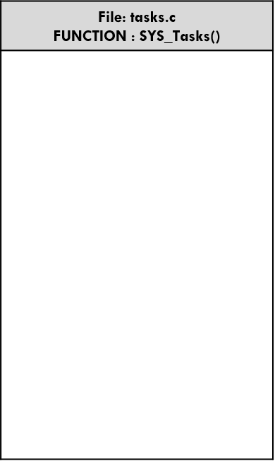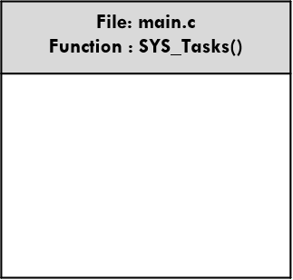

TCPIP_STACK_Tasks ()

APP_Tasks ()

SYS_CMD_TASKS()

SYS_FS_TASKS()

DRV_MIIM_TASKs ()

NET_PRES_Tasks ()

SYS_FS_TASKS()

NET_PRES_Tasks ()

## Lab Procedure

In Lab 1, you configured a new MPLAB Harmony Project from scratch that included the TCP/IP Stack middleware and a LED Flasher. The project you created in Lab 1 will be used as the starting point for Lab 2.. The source code for the OLED and Button Controller are included into the project.

You will learn about several Harmony TCP/IP API functions by adding the necessary APIs into the application source code to manage the TCP Sockets and data exchanged with socket. You will also learn how the dynamic variables in a web page are handled by the server. Finally, you will get to use the Packet Sender software tool to perform isolated testing of the embedded application prior to connecting your VM implementation to the server on the network.

Lab Procedure

Project Setup

* 1. Close Lab 1 project by choosing File⮞Close Project(lab1) in the main menu.

|  |
| --- |
|  |

* 1. The project for Lab 2 has already been setup in advance. The project is a working implementation of Lab 1 that has been renamed to web_net_server_nvm_mpfs_lab2, and has a number of files added including mmi.c and modified app.c file are added to the project. To open the Lab 2 project, choose File⮞Open Project in the main menu.

|  |
| --- |
|  |

* 1. In the Open Project window, enter C:\MASTERs\21070\ web_net_server_nvm_mpfs_lab2\firmware into the File name text box or navigate to the file .
  2. Click on sam_e70_xult_freetos.X icon in the file list.
  3. 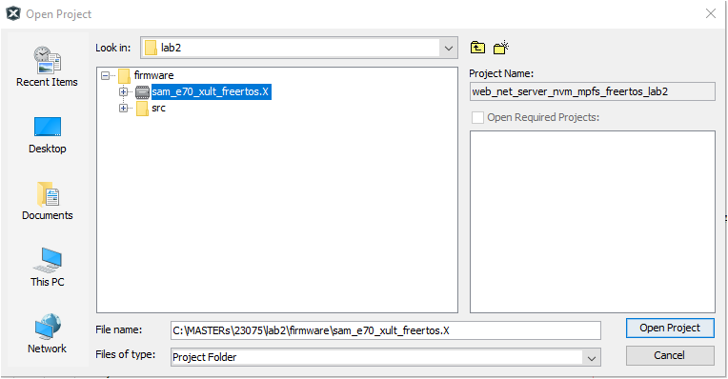Press Open Project.

|  |
| --- |
|  |

* 1. The source and header structure for the project is shown below.

|  |
| --- |
|  |

MHC Code Generation

* 1. The project configurations are already set, and we are going to look on the configurations and generate the code. (steps 1.8 -1.22)
  2. Before the MHC Configuration tool can be used, you need to set lab2 as the main project, by right clicking on the web_net_server_nvm_mpfs_lab2 folder under the Projects window, and choosing Set as Main Project in the popup menu.

|  |  |
| --- | --- |
|  |  |

* 1. To launch MHC, choose Tools⮞Embedded⮞MPLAB Harmony 3 Configurator in the main menu.

|  |
| --- |
|  |

* 1. In the MPLAB Harmony Launcher dialog box, make sure the path states   
     C:\MASTERs\23075\h3 and click on Launch.

|  |
| --- |
|  |

* 1. In the nest window the H3 parts and their used Version Number are displayed. Click on Launch
  2. Open the saved state file

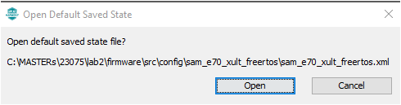

* 1. Explore and look on the configurations tree by clicking on the modules under Active Components (step 1.14 and 1.15- can be skipped and continue from 1.16).
  2. Click and check the “**Core”** option under Active Components. On right hand side the Configuration options are displayed, check the “Number of Applications “options under Configuration Options which is set to 2.Expand both Application 0 and 1 Configuration trees, and the Application Name is set to app (Application Interface) for Application 0, and mmi(Man Managed Interface for buttons, leds and OLED)for Application 1.
  3. Check on TCP/IP Stack under Active components and its configuration under Configuration options.

|  |
| --- |
|  |

* 1. Select the **Instance 0** in the **TCP/IP stack** under **Active Components** to enter the HOST Name **(TCP/IP STACK->BASIC CONFIGURATION->Instance 0).** And change in the **Configuration Options** (displayed on the right side of MPlabx) the Host Name to your firstname_lastname. The Host name can be identified in the Network.



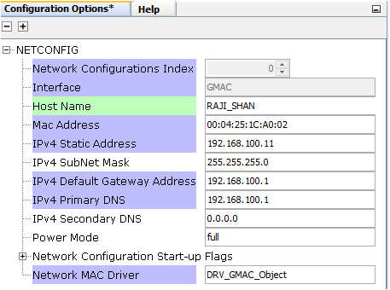

* 1. Select “Code” (Generate Code) which is under the menu tabs.  
     
  2. Select Don’t Save  
     
  3. Select Generate  
     
  4. Some Files will be changed, and the MHC is asking in a “diff” window, if the changes should be taken over. Accept all changes in the file by clicking on the Arrow in the middle above and then close.

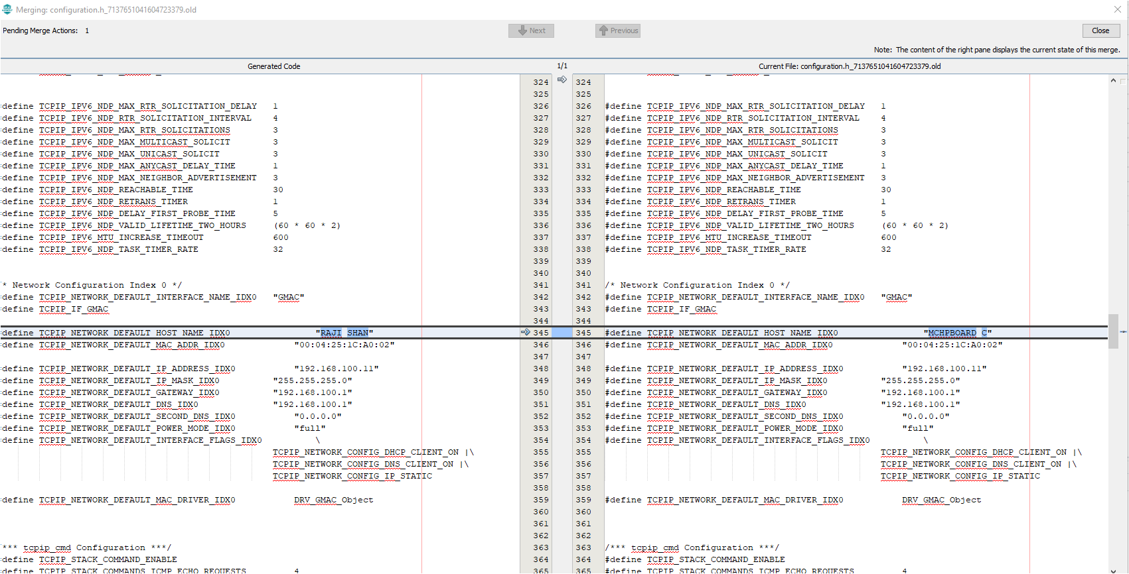

1

2

* 1. The whole process is displayed with a progress bar  
     
  2. After the MHC has finished generating the project, go to the Projects Window and expand the Header Files and Source Files to see the source/header files for the *app and mmi* application file and TCP/IP stack files.
* The WEB page source code for the VM application is found under the folder web-pages->VM.htm
* The hex file for the web page is in mpfs_net_img.c which is generated using the utility MPFS- generator which comes along with Harmony net package.

|  |
| --- |
|  |

Application Source and Header File SetupTASK1:

In the VM application when an VM ITEM update is initiated by the HTTP- client (WEB PAGE) it sends out a GET command that needs to be processed by the HTTP-Server. The get command is sent along with the argument of the VM “Item” to be updated and its “Count” which are processed by the HTTP-Server. In Harmony TCP/IP stack GET command is handled by the function TCPIP_HTTP_NET_ConnectionGetExecute ().

Follow the procedure under to include the code that process the GET request from HTTP-CLient: -

* 1. Click and Open the file custom_http_net_app.c. Search for the function TCPIP_HTTP_NET_ConnectionGetExecute () (Approx. Line.No. 247) in which the below code snippets need to be inserted.

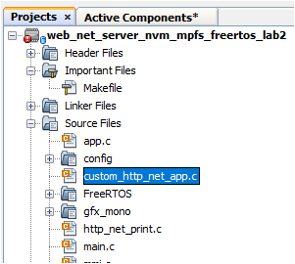

* 1. Find the TODO[1] and insert the below code starting from the line mentioned as ***“//<--Insert the solution for TODO[4] starting on this line”*** . Code can be inserted either by typing or copy and paste which is provided for your convenience at the end of the file (custom_http_net_app.c).

ptr = TCPIP_HTTP_NET_ArgGet(httpDataBuff, (const uint8_t *)"ITEM");

* 1. Find the TODO[2] and insert the code snippet starting from the line mentioned as ***“//<--Insert the solution for Item 2 starting on this line”*** . Code can be inserted either by typing or copy and paste which is provided for your convenience at the end of the file (custom_http_net_app.c).

ptr = TCPIP_HTTP_NET_ArgGet(httpDataBuff, (const uint8_t *)"COUNT");

VM_Count[Update_Item]=*ptr;

TASK 2:

When a Bay of the VM is empty it sends out the message to the common server. The sate machine to open a socket to send message and close socket is shown below

**Stack Initialized**

**NO**

**YES**

**File Mounted**

**No link found**

**If new link found**

**Stack not Initialized**

**If MAC address is not read**

**MAC address READ**

**If WEB file is not mounted**

**not mounted**

READ

MAC address

TCP/IP stack Int

**Link is established**

**Connection Established**

**If wait time out**

Send out the TCP message

“Bay is empty”

Close connection

Set-up TCP client

Display the IP address

In this section, you will gain some experience with the use of Harmony TCP/IP API functions. The app.c source is missing lines of code. All missing code specifically relates to management of the setting up the TCP Client such as opening or closing the socket, checking if the socket is connected, checking if data is available, and writing data to the socket. Your task is to read the description for each missing item, select the appropriate Harmony TCP/IP API, and fill in the missing line of code.

* 1. The first step to do is get the **common server’s IP address**. Get the address from the presenter and make a note.
  2. Click and Open the file app.c. and find the function APP_Tasks (). (Approx. Line.No. 200) in which the below code snippets are inserted.

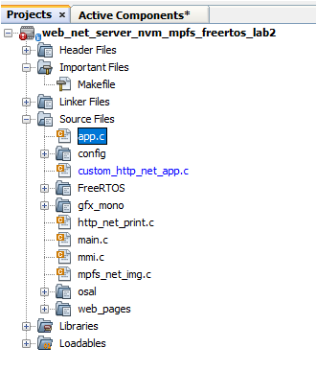

* 1. Find the TODO[3] in which common SERVER IP address is entered. Replace the x with the common server IP address ().

For example: if the server IP address is 192.168.0.108 replace

* x1 with 192

* x2 with 168

* x3 with 0

* x4 with 108

* 1. Find TODO[4] and add the below snippet to Open a socket for TCP_Client . Code can be inserted either by typing or copy and paste the code which is provided for your convenience at the end of the file (app.c).

appData.socket = TCPIP_TCP_ClientOpen(IP_ADDRESS_TYPE_IPV4,

appData.port,

(IP_MULTI_ADDRESS*) & addr);

* 1. Find TODO[5] and add the below snippet to check the TCP connection is established 0.

Insert the code in the line mentioned as ***“//<--Insert the solution for TODO[5] starting on this line”***

Code can be inserted either by typing or copy and paste the code which is provided for your convenience at the end of the file (app.c).

if (!TCPIP_TCP_IsConnected(appData.socket))

* 1. Find TODO[6] and add the below snippet to check the TCP connection is established .

Insert the code in the line mentioned as ***“//<--Insert the solution for TODO[6] starting on this line”***

Code can be inserted either by typing or copy and paste the code which is provided for your convenience at the end of the file (app.c).

if (TCPIP_TCP_PutIsReady(appData.socket) == 0)

* 1. Find TODO[7] and add the below snippet to send the message to the common server once a TCP connection at port 80 is established .

Insert the code in the line mentioned as ***“//<--Insert the solution for TODO[7] starting on this line”***

Code can be inserted either by typing or copy and paste the code which is provided for your convenience at the end of the file (app.c).

sprintf(buffer, "MSG:%d from %s : %s is empty", (int) MessageCounter++, (char *) TCPIP_HOSTS_CONFIGURATION[0].macAddr, (char *) VM_Items[bay_index - 1]);

SYS_CONSOLE_PRINT("Sending message: %s\r\n", buffer);

TCPIP_TCP_ArrayPut(appData.socket, (uint8_t*) buffer, strlen(buffer));

* 1. Find TODO[8] and add the below snippet to close the TCP Client socket.

Insert the code in the line mentioned as ***“//<--Insert the solution for TODO[8] starting on this line”***

Code can be inserted either by typing or copy and paste the code which is provided for your convenience at the end of the file (app.c).

TCPIP_TCP_Close(appData.socket);

Hardware Setup

This hardware setup is common to both TASK1 and TASK2. After adding the required code for the application, make the hardware connections to programme the device and to see the output



CLASS ETHERNET NETWORK





|  |
| --- |
| * 1. Network Connection   Cable: CAT5 Ethernet Cable supplied with Starter Kit  Connection: RJ45 Jack from the class network to PCB Top RJ45 Jack(make sure the jumper below the Ethernet PHY module is taken off) |
| * 1. Programming and Console Connection   CableUSB Male A to USB Male B Micro cable  Connection: USB Debug Port on PCB Top to Laptop USB Port |
| * 1. OLED1 Xplained Pro Connection   OLED1 X PLAINED PRO  Connection: Connect the OLED x PLAINED PRO to the EXT 2 of the board (Extension close to Ethernet PHY)   * 1. PC   PC needs to be connected to the Class network or  It can be connected to the wireless network |

* 1. In the main window of MPLABX, click on the “Make and Program Device” button  
     

|  |
| --- |
|  |

* 1. After successful build, the SAME70 is programmed automatically. Build and Programming are monitored on the output window at the bottom of the MPLAB X IDE screen.

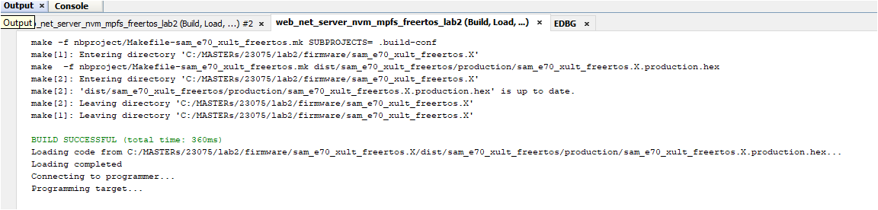

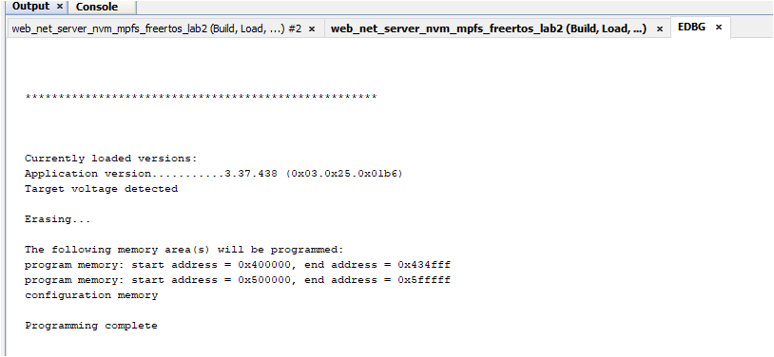

* 1. Immediately after programming, you can see the text on the OLED screen in series like the screens below.

Use the Buttons 1 and 2 (Previous and Next item) on the OLED1 Xplained pro to scroll through the items of the Vending Machine.

Welcome to

23075 IoT6

Vending

Machine

B1-UP, B2-Down

B3-Select

1.Coco-Cola

9

* 1. Now open a Tera Term to see the status of the HTTP server and its IP address.

If Tera Term is still open from Lab 1, click on the window title bar to make it active. If Tera Term needs to be re-opened and configured, refer the below steps.

Open Terra Term Terminal Program  and select under” **Setup->Serial Port”** (in this case a COM14, but could be a different COM Port number in your case) set the speed to 115200.Match the below set-up and click “OK”

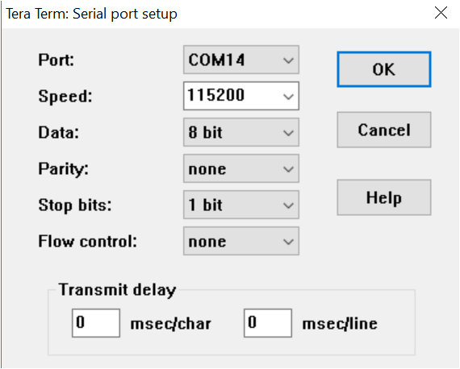

* 1. Reset the Board and let the Firmware restart.



RESET SW401

|  |
| --- |
|  |

* 1. After some small time, the IP Address should change from 0.0.0.0 to a valid address. Take time to go through the Initialization messages, MAC address, Host name and the IP address of the HTTP- server displayed on the tera term terminal.

|  |
| --- |
|  |

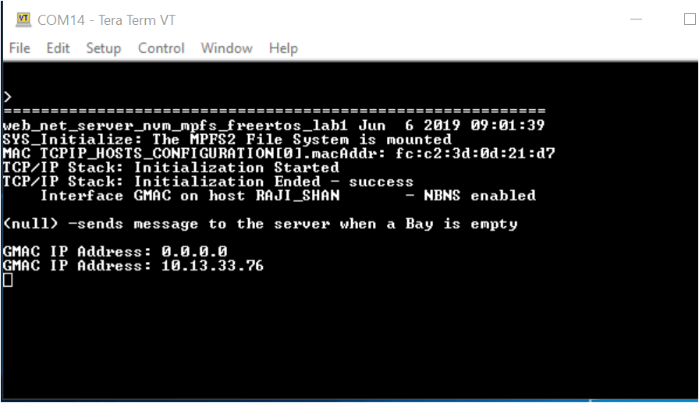

* 1. Open a web browser and enter the HTTP- Server IP address that you got on the tera term in the previous step. This opens a web page (HTTP-Client)



* 1. 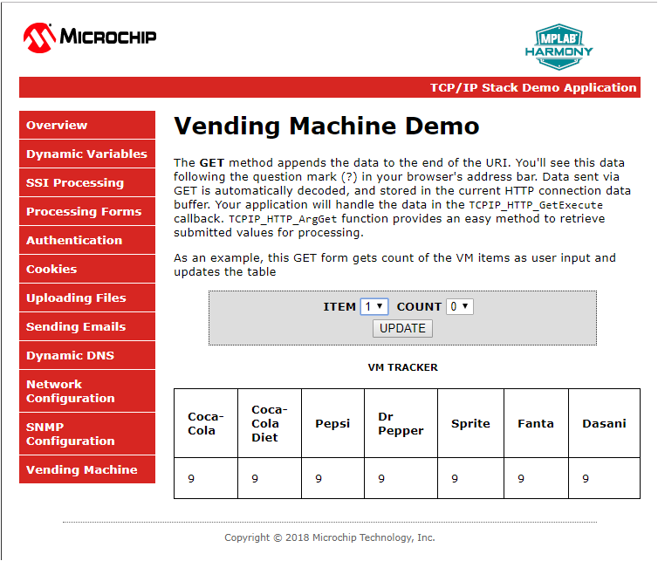Click on the Vending Machine tab to see the page for the Vending Machine Demo.



|  |
| --- |
|  |

|  |
| --- |
| * 1. Use the Button 3 on the OLED to pick an item from the VM. The count of the corresponding item on the OLED scren will be decremented by 1 and is reflected on the Web page as well as on the OLED screen.   1.Coco-Cola  8 |

* 1. Check on the VM update. Pick an item and the count to be changed on the WEB page from the **ITEM** and **COUNT** drop down menu. Select update. When an update is selected the WEB page will send a GET command along with the ITEM number and COUNT to the HTTP-server. The HTTP-server decodes the GET command and displays it on the VM diaply (OLED).

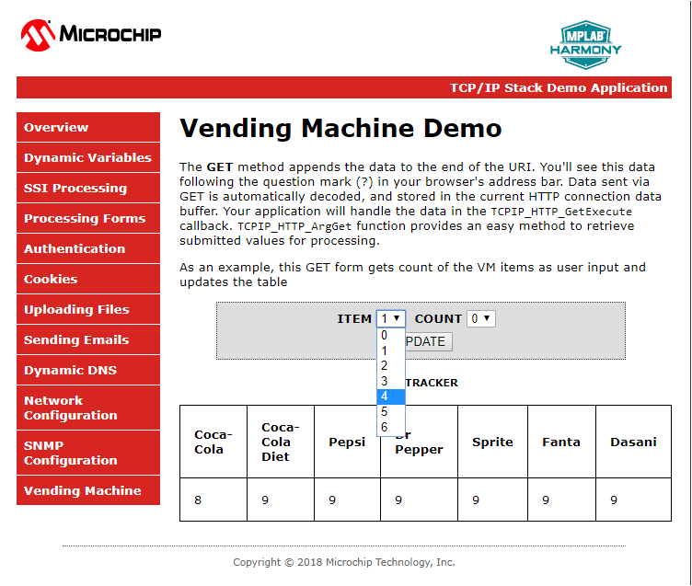

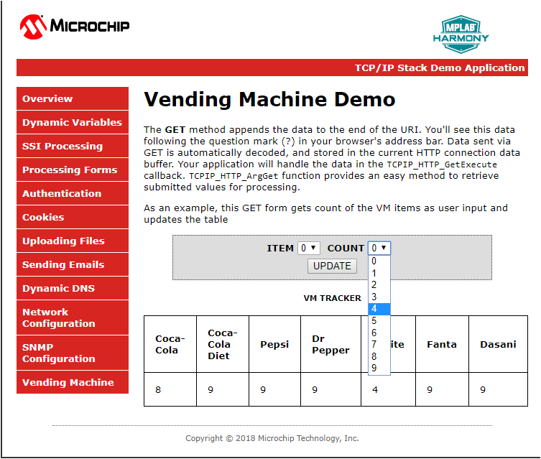

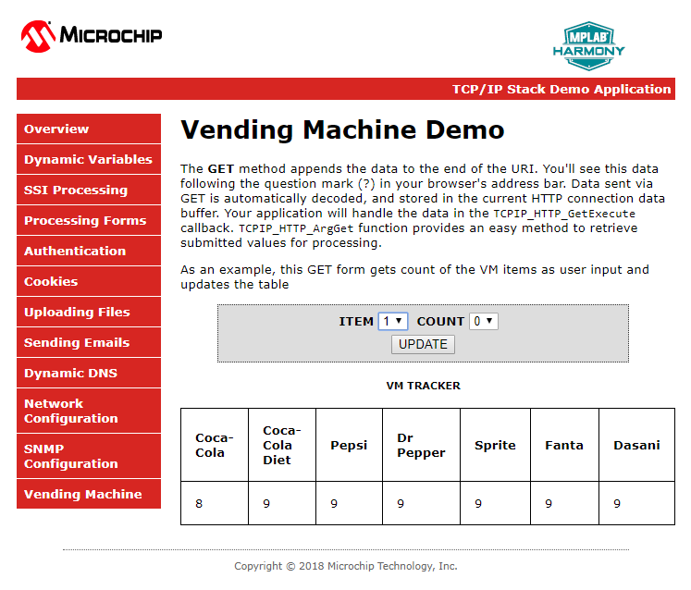

Example:

On the web page ITEM 4 and its count will be changed to 4 and, also on the OLED.

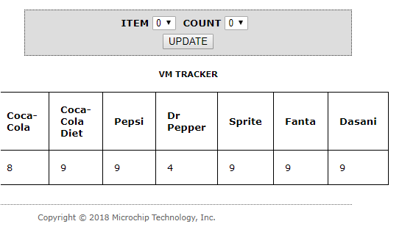

4

4. Dr Pepper

You have successfully completed TASK 1 and let’s move on to TASK 2.

* 1. To test Task 2, one or more Bay of the VM machine must be Zero. Press the select Button 3 and make one or more item to zero count. After few second you can see the messages ” Sending VM status “ , “Starting Connection” and “TCP Socket Connected” and the “BAY Empty message” and TCP client closed on the tera term.
  2. Look at the presenter’s screen to identify your message.

MSG:338 from fc:c2:3d:0d:21:d7 : 2.Diet-Coke is empty

Message No. MAC address which is unique for each VM Bay empty message

# Lab 3

## Overview

In many IoT applications, JSON is commonly used as a format in order to transport high-level data in an effective way. It is generally an alternative to XML. Consider the following example of describing a person named Raji-Niklas Ruppert in JSON-format:

{

“firstName” : “Raji-Niklas”,

“lastName” : “Ruppert”,

“age” : 30,

“address” : {

“streetAddress” : “2355 W Chandler Blvd”,

“city” : “Chandler”,

“state” : “AZ”,

“postalCode” : “85224”,

}

}

Using this format makes it very easy to communicate between applications requiring information about Raji-Niklas Ruppert.

The advantage of using JSON in embedded applications is that because it is easy to read for humans, it is simple to parse and make use of. Due to this, it is commonly used to transmit data between a server and a web application. In this lab we are going to implement an embedded application fetching weather data from a web server. When the application accesses a specific URL specifying a command with a geographic location, the web server will respond by sending the current weather in JSON-format to the web application. The application will be running on our SAME70-boards.

In this lab we will only do very simple parsing (which is one of the strengths using JSON), using standard string operations. There are however more sophisticated parsers which can be used for more robust and complex applications, while still only consuming a very limited footprint.

The weather service used in this lab is <https://openweathermap.org/>. With OpenWeatherMap, there are several services such as hourly forecast, UV Index, Air pollution and more, all outputting in JSON. With the free account there are limited option to only use the “Current Weather Data” service. With this service you can request the current weather from different geographic locations. Depending on by which method (City ID, ZIP Code, Coordinates etc.) the URL call will be slightly different. A full description of the API can be found here: <https://openweathermap.org/current>. For this lab we will fetch current weather by city. The following URL for this is:

http://api.openweathermap.org/data/2.5/weather?q=**{CITY}**&APPID=**{API Key}**

The API Key is unique to each user. This is also how OpenWeatherMap tracks how many requests you attempt. The API Key is a 15-byte long hexadecimal string. It can look like this:

ed3da58111974261002c2af4f8e8e81f

In most JSON API:s there is also a well defined format specified, which tells you where the different objects and strings are located in the JSON-message. From OpenWeatherMap:

{"coord":{"lon":-122.09,"lat":37.39},

"sys":{"type":3,"id":168940,"message":0.0297,"country":"US","sunrise":1427723751,"sunset":1427768967},

"weather":[{"id":800,"main":"Clear","description":"Sky is Clear","icon":"01n"}],

"base":"stations",

"main":{"temp":285.68,"humidity":74,"pressure":1016.8,"temp_min":284.82,"temp_max":286.48},

"wind":{"speed":0.96,"deg":285.001},

"clouds":{"all":0},

"dt":1427700245,

"id":0,

"name":"Mountain View",

"cod":200}

Application Flow

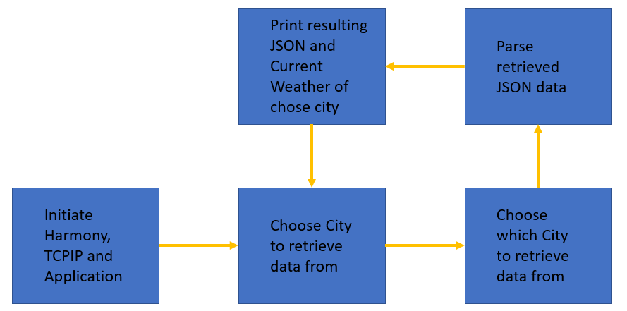

#### Lab Outline

* In the the source code file app,c are TODO’s. At this places you have to change the source codes. At the bottom of the app.c you find the solutions. Either you think about what you have to change, or you just copy the solution at the right place.
* The main purpose of this class is to point you to the crucial points in an Harmony 3 application and not to let you write a complete TCP application
* The pre-made template is built from the Harmony example project, tcpip_tcp_client.
* First, we will need to declare the APPID_KEY.
* We will then set the host & port of the remote connection static as we will only connect to OpenWeatherMap.
* After this, we will redirect the user input from the command console to a char* buffer to be used in the application.
* Now we have all information required to build the URL from the introduction.
* When we have connected and requested the data, we need to parse the resulting JSON- string (the whole JSON containing the current weather will be in one string).
* Typically, good practice when you debug JSON-strings is to print the resulting string for you to view with your own eyes that it looks correct.
* At last, redirect the application to go back to accepting user input.

## Lab Procedure

1. Start by closing any open projects in MPLAB X IDE.
2. Open a new project and choose lab3 -> Firmware -> sam_e70_xult_freertos.X.
3. Open the file app.c located under source files.
4. Go to (CTRL+F) “TODO A”. Enter the correct APPID_KEY. Either you create your own account on OpenWeatherMap or you take the one written I the class.

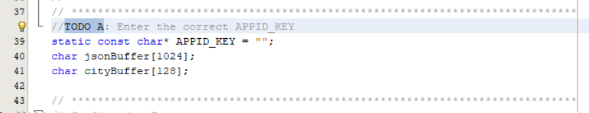

1. Now scroll down to “TODO B”, the function APP_Initialize.
2. Set the application to connect to the host api.openweathermap.org and the port to 80. This is set to 80 because this call will be over HTTP.

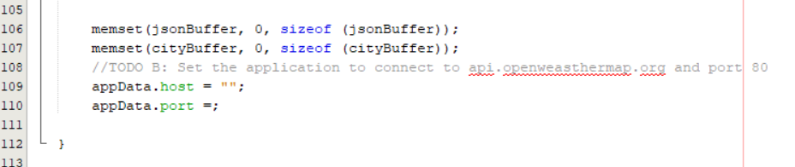

1. Re-direct the user input from APP_URL_BUFFER to the cityBuffer array. This can be done in several ways, but one is to use the built-in C function **snprintf**(char* dest, size_t size, const char *format, …). The first argument is the destination buffer (cityBuffer), the second one is the max size to be copied (128, because that is specified in the declaration) and the formatted input in this scenario is APP_URL_BUFFER. This can be found in “TODO C”.

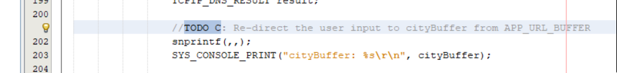

1. Scroll down to “TODO D”, the state APP_TCPIP_WAIT_FOR_CONNECTION. In this state we will wait for a connection to be established. Once established we will send a GET command with the full URL in the format specified in the introduction:

http://api.openweathermap.org/data/2.5/weather?q=**{CITY}**&APPID=**{API Key}**.

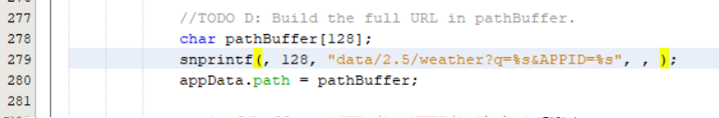

1. Once the request is sent to the server, the application will go into the APP_TCIPIP_WAIT_FOR_RESPONSE state. Once the connection is closed, set the next state to be APP_STATE_JSON_PARSE_RETRIEVED_DATA.

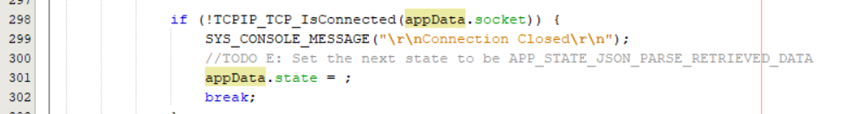

1. Now go down in the state APP_STATE_JSON_PARSE_RETRIEVED_DATA. One of the first things we want to do after we have sorted out the JSON-part of the retrieved data is to print the raw JSON-string. This helps us debug & analyse.

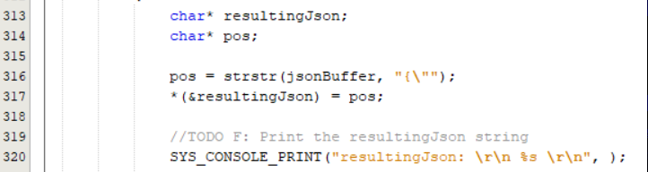

1. In a real application, we would need to first know the format of the JSON message in order to be able to parse it correctly. To make this lab more efficiently, we will do this backwards. If you look at this example piece of API response from OpenWeatherMap found in the introduction section to this lab. Looking at the format from the API, we need to calculate in what position the value of humidity start. The function strstr will cut the resulting Json string at the first occurrence of “humidity”. A hint is to look at the other blocks where you parse the temperature, pressure and main weather.

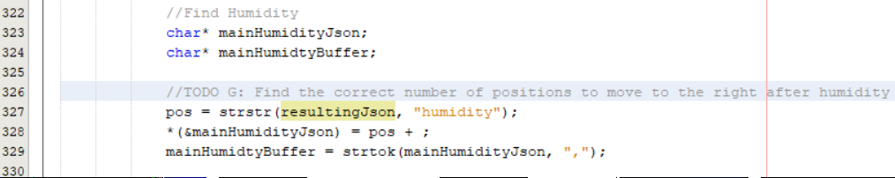

1. Once the parsing is done, we wish to print the values of the main weather, pressure, temperature and humidity.



1. Now to complete the loop, we want to go back to the APP_TCPIP_WAITING_FOR_COMMAND state once the JSON-parsing and printing is done. 
2. When the build process was correct, then program the E70
3. Open the Terminal program, press the Reset Button
4. When “>” is prompter you can put in “requestWeather <city>”  
   Or the short form: ”rw <city>”  
   For ex. “rw Phoenix”  
   
5. At this point you reached the end of the class and can walk outside to check if the current weather report was correct

# MPLAB® Harmony TCP/IP Stack

## TCP Module API Function List

Socket Management Functions

|  |  |
| --- | --- |
| **TCPIP_TCP_ServerOpen** | Opens a TCP socket as a server. |
| **TCPIP_TCP_ClientOpen** | Opens a TCP socket as a client. |
| **TCPIP_TCP_Close** | Disconnects an open socket and destroys the socket handle, releasing the associated resources. |
| **TCPIP_TCP_Connect** | Connects a client socket. |
| **TCPIP_TCP_Bind** | Binds a socket to a local address. |
| **TCPIP_TCP_RemoteBind** | Binds a socket to a remote address. |
| **TCPIP_TCP_IsConnected** | Determines if a socket has an established connection. |
| **TCPIP_TCP_WasReset** | Self-clearing semaphore indicating socket reset. |
| **TCPIP_TCP_Disconnect** | Disconnects an open socket. |
| **TCPIP_TCP_Abort** | Aborts a connection. |
| **TCPIP_TCP_OptionsGet** | Allows getting the options for a socket like: current RX/TX buffer size, etc. |
| **TCPIP_TCP_OptionsSet** | Allows setting options to a socket like adjust RX/TX buffer size, etc. |
| **TCPIP_TCP_SocketInfoGet** | Obtains information about a currently open socket. |
| **TCPIP_TCP_SocketNetGet** | Gets the current network interface of an TCP socket. |
| **TCPIP_TCP_SocketNetSet** | Sets the interface for an TCP socket |
| **TCPIP_TCP_SignalHandlerDeregister** | Deregisters a previously registered TCP socket signal handler. |
| **TCPIP_TCP_SignalHandlerRegister** | Registers a TCP socket signal handler. |
| **TCPIP_TCP_Task** | Standard TCP/IP stack module task function. |

Transmit Data Functions

|  |  |
| --- | --- |
| **TCPIP_TCP_Put** | Writes a single byte to a TCP socket. |
| **TCPIP_TCP_PutIsReady** | Determines how much free space is available in the TCP TX buffer. |
| **TCPIP_TCP_StringPut** | Writes a null-terminated string to a TCP socket. |
| **TCPIP_TCP_ArrayPut** | Writes an array from a buffer to a TCP socket. |
| **TCPIP_TCP_Flush** | Immediately transmits all pending TX data. |
| **TCPIP_TCP_FifoTxFullGet** | Determines how many bytes are pending in the TCP TX FIFO. |
| **TCPIP_TCP_FifoTxFreeGet** | Determines how many bytes are free and could be written in the TCP TX FIFO. |

Receive Data Transfer Functions

|  |  |
| --- | --- |
| **TCPIP_TCP_ArrayFind** | Searches for a string in the TCP RX buffer. |
| **TCPIP_TCP_Find** | Searches for a byte in the TCP RX buffer. |
| **TCPIP_TCP_Get** | Retrieves a single byte to a TCP socket. |
| **TCPIP_TCP_Peek** | Peaks at one byte in the TCP RX buffer/FIFO without removing it from the buffer. |
| **TCPIP_TCP_Discard** | Discards any pending data in the RCP RX FIFO. |
| **TCPIP_TCP_FifoRxFreeGet** | Determines how many bytes are free in the RX buffer/FIFO. |
| **TCPIP_TCP_FifoSizeAdjust** | Adjusts the relative sizes of the RX and TX buffers. |
| **TCPIP_TCP_FifoRxFullGet** | Determines how many bytes are pending in the RX buffer/FIFO. |
| **TCPIP_TCP_GetIsReady** | Determines how many bytes can be read from the TCP RX buffer. |
| **TCPIP_TCP_ArrayGet** | Reads an array of data bytes from a TCP socket's RX buffer/FIFO. |
| **TCPIP_TCP_ArrayPeek** | Reads a specified number of data bytes from the TCP RX buffer/FIFO without removing them from the buffer. |

## UDP Module API Function List

Socket Management Functions

|  |  |
| --- | --- |
| **TCPIP_UDP_ServerOpen** | Opens a UDP socket as a server. |
| **TCPIP_UDP_ClientOpen** | Opens a UDP socket as a client. |
| **TCPIP_UDP_IsOpened** | Determines if a socket was opened. |
| **TCPIP_UDP_IsConnected** | Determines if a socket has an established connection. |
| **TCPIP_UDP_Bind** | Bind a socket to a local address and port. This function is meant for client sockets. It assigns a specific source address and port for a socket. |
| **TCPIP_UDP_RemoteBind** | Bind a socket to a remote address This function is meant for server sockets. |
| **TCPIP_UDP_Close** | Closes a UDP socket and frees the handle. |
| **TCPIP_UDP_OptionsGet** | Allows getting the options for a socket such as current RX/TX buffer size, etc. |
| **TCPIP_UDP_OptionsSet** | Allows setting options to a socket like adjust RX/TX buffer size, etc |
| **TCPIP_UDP_SocketInfoGet** | Returns information about a selected UDP socket. |
| **TCPIP_UDP_SocketNetGet** | Gets the network interface of an UDP socket |
| **TCPIP_UDP_SocketNetSet** | Sets the network interface for an UDP socket |
| **TCPIP_UDP_TxOffsetSet** | Moves the pointer within the TX buffer. |
| **TCPIP_UDP_SourceIPAddressSet** | Sets the source IP address of a socket |
| **TCPIP_UDP_BcastIPV4AddressSet** | Sets the broadcast IP address of a socket Allows an UDP socket to send broadcasts. |
| **TCPIP_UDP_DestinationIPAddressSet** | Sets the destination IP address of a socket |
| **TCPIP_UDP_DestinationPortSet** | Sets the destination port of a socket |
| **TCPIP_UDP_Disconnect** | Disconnects a UDP socket and re-initializes it. |
| **TCPIP_UDP_SignalHandlerDeregister** | Deregisters a previously registered UDP socket signal handler. |
| **TCPIP_UDP_SignalHandlerRegister** | Registers a UDP socket signal handler. |
| **TCPIP_UDP_Task Standard** | TCP/IP stack module task function. |

Transmit Data Functions

|  |  |
| --- | --- |
| **TCPIP_UDP_PutIsReady** | Determines how many bytes can be written to the UDP socket. |
| **TCPIP_UDP_TxPutIsReady** | Determines how many bytes can be written to the UDP socket. |
| **TCPIP_UDP_ArrayPut** | Writes an array of bytes to the UDP socket. |
| **TCPIP_UDP_StringPut** | Writes a null-terminated string to the UDP socket. |
| **TCPIP_UDP_Put** | Writes a byte to the UDP socket. |
| **TCPIP_UDP_TxCountGet** | Returns the amount of bytes written into the UDP socket. |
| **TCPIP_UDP_Flush** | Transmits all pending data in a UDP socket. |

Receive Data Transfer Functions

|  |  |
| --- | --- |
| **TCPIP_UDP_GetIsReady** | Determines how many bytes can be read from the UDP socket. |
| **TCPIP_UDP_ArrayGet** | Reads an array of bytes from the UDP socket. |
| **TCPIP_UDP_Get** | Reads a byte from the UDP socket. |
| **TCPIP_UDP_RxOffsetSet** | Moves the read pointer within the socket RX buffer. |
| **TCPIP_UDP_Discard** | Discards any remaining RX data from a UDP socket. |

# Harmony TCP/IP API Subset For all Lab’s

## TCP Socket Management Functions

TCPIP_TCP_ArrayGet Function

This function reads an array of data bytes from a TCP socket's RX buffer/FIFO. The data is removed from the FIFO in the process.

Function Prototype

|  |
| --- |
| uint16_t **TCPIP_TCP_ArrayGet**(  [TCP_SOCKET](mk:@MSITStore:D:\microchip\harmony\v1_08\doc\help_harmony.chm::/22209.html) **hTCP**,  uint8_t* **buffer**,  uint16_t **len**  ); |

#### Preconditions

TCP is initialized.

#### Parameters

|  |  |
| --- | --- |
| **Parameter** | **Description** |
| ****hTCP**** | The socket from which data is to be read. |
| ****buffer**** | Pointer to the array to store data that was read. |
| ****len**** | Number of bytes to be read. |

#### Returns

|  |  |
| --- | --- |
| **Type** | **Description** |
| uint16_t | The number of bytes read from the socket. If less than len, the RX FIFO buffer became empty or the socket is not connected. |

TCPIP_TCP_ClientOpen Function

Provides a unified method for opening TCP client sockets. Sockets are created at the TCP module initialization, and can be claimed with this function and freed using TCPIP_TCP_Abort or TCPIP_TCP_Close. If the remoteAddress != 0 (and the address pointed by remoteAddress != 0) then the socket will immediately initiate a connection to the remote host.

#### Function Prototoype

|  |
| --- |
| [TCP_SOCKET](mk:@MSITStore:D:\microchip\harmony\v1_08\doc\help_harmony.chm::/22209.html) **TCPIP_TCP_ClientOpen**(  [IP_ADDRESS_TYPE](mk:@MSITStore:D:\microchip\harmony\v1_08\doc\help_harmony.chm::/14165.html) **addType**,  [TCP_PORT](mk:@MSITStore:D:\microchip\harmony\v1_08\doc\help_harmony.chm::/22208.html) **remotePort**,  [IP_MULTI_ADDRESS](mk:@MSITStore:D:\microchip\harmony\v1_08\doc\help_harmony.chm::/14171.html)* **remoteAddress**  ); |

#### Preconditions

TCP is initialized.

#### Parameters

|  |  |
| --- | --- |
| **Parameter** | **Description** |
| **addType** | The type of address being used. Valid values are: IP_ADDRESS_TYPE_IPV4 or IP_ADDRESS_TYPE_IPV6 |
| **remotePort** | TCP port to connect to. The local port for client sockets will be automatically picked by the TCP module. |
| **remoteAddress** | The remote address to be used |

#### Returns

|  |  |
| --- | --- |
| **Type** | **Description** |
| [TCP_SOCKET](mk:@MSITStore:D:\microchip\harmony\v1_08\doc\help_harmony.chm::/22209.html) | Handle - Save this handle and use it when calling all other TCP APIs. If no sockets of the specified type were available to be opened, the handle will contain a value equal to INVALID_SOCKET. |

TCPIP_TCP_Close Function

Graceful Option Set: If the graceful option is set for the socket (default), a TCPIP_TCP_Disconnect will be tried. If the linger option is set (default) the TCPIP_TCP_Disconnect will try to send any queued TX data before issuing FIN. If the FIN send operation fails or the socket is not connected the abort is generated.

Graceful Option Not Set: If the graceful option is not set, or the previous step could not send the FIN, a TCPIP_TCP_Abort is called, sending a RST to the remote node. Communication is closed, the socket is no longer valid and the associated resources are freed.

#### Function Prototype

|  |
| --- |
| **void** **TCPIP_TCP_Close**(  [TCP_SOCKET](mk:@MSITStore:D:\microchip\harmony\v1_08\doc\help_harmony.chm::/22209.html) **hTCP**  ); |

#### Preconditions

TCP socket should have been opened with TCPIP_TCP_ServerOpen/TCPIP_TCP_ClientOpen.

hTCP - valid socket

#### Parameters

|  |  |
| --- | --- |
| **Parameter** | **Description** |
| hTCP | Handle to the socket to disconnect and close. |

#### Returns

|  |  |
| --- | --- |
| **Type** | **Description** |
| Void | None |

TCPIP_TCP_GetIsReady Function

Call this function to determine how many bytes can be read from the TCP RX buffer. If this function returns zero, the application must return to the main stack loop before continuing in order to wait for more data to arrive.

#### Function Prototype

|  |
| --- |
| uint16_t **TCPIP_TCP_GetIsReady**(  [TCP_SOCKET](mk:@MSITStore:D:\microchip\harmony\v1_08\doc\help_harmony.chm::/22209.html) **hTCP**  ); |

#### Preconditions

TCP is initialized.

#### Parameters

|  |  |
| --- | --- |
| **Parameter** | **Description** |
| **hTCP** | The socket to check. |

#### Returns

|  |  |
| --- | --- |
| **Type** | **Description** |
| uint16_t | The number of bytes available to be read from the TCP RX buffer. |

TCPIP_TCP_IsConnected Function

This function determines if a socket has an established connection to a remote node. Call this function after calling TCPIP_TCP_ServerOpen()/TCPIP_TCP_ClientOpen() to determine when the connection is set up and ready for use.

#### Function Prototype

|  |
| --- |
| **bool** **TCPIP_TCP_IsConnected**(  [TCP_SOCKET](mk:@MSITStore:D:\microchip\harmony\v1_08\doc\help_harmony.chm::/22209.html) **hTCP**  ); |

#### Preconditions

TCP is initialized.

#### Parameters

|  |  |
| --- | --- |
| **Parameter** | **Description** |
| hTCP | The TCP socket to check. |

#### Returns

|  |  |
| --- | --- |
| **Type** | **Description** |
| bool | True: the socket is connected  False: the socket is disconnected |

TCPIP_TCP_PutIsReady Function

Call this function to determine how many bytes can be written to the TCP TX buffer. If this function returns zero, the application must return to the main stack loop before continuing in order to transmit more data.

#### Function Prototype

|  |
| --- |
| uint16_t **TCPIP_TCP_PutIsReady**(  [TCP_SOCKET](mk:@MSITStore:D:\microchip\harmony\v1_08\doc\help_harmony.chm::/22209.html) **hTCP**  ); |

#### Preconditions

TCP is initialized.

#### Parameters

|  |  |
| --- | --- |
| **Parameter** | **Description** |
| **hTCP** | The socket from which data is to be written. |

#### Returns

|  |  |
| --- | --- |
| **Type** | **Description** |
| uint16_t | The number of bytes available to be written in the TCP TX buffer. |

TCPIP_TCP_StringPut Function

This function writes a null-terminated string to a TCP socket. The null-terminator is not copied to the socket.

#### Function Prototype

|  |
| --- |
| **const** uint8_t* **TCPIP_TCP_StringPut**(  [TCP_SOCKET](mk:@MSITStore:D:\microchip\harmony\v1_08\doc\help_harmony.chm::/22209.html) **hTCP**,  **const** uint8_t* **Data**  ); |

#### Preconditions

TCP is initialized.

#### Parameters

|  |  |
| --- | --- |
| **Parameter** | **Description** |
| **hTCP** | The socket from which data is to be written. |
| **const** uint8_t* | **Data** |

#### Returns

|  |  |
| --- | --- |
| **Type** | **Description** |
| **const** uint8_t* | Pointer to the byte following the last byte written to the socket. If this pointer does not dereference to a NULL byte, the buffer became full or the socket is not connected. |

TCPIP_TCP_WasReset Function

This function is a self-clearing semaphore indicating whether or not a socket has been disconnected since the previous call. This function works for all possible disconnections: a call to [TCPIP_TCP_Disconnect](mk:@MSITStore:D:\microchip\harmony\v1_08\doc\help_harmony.chm::/24093.html), a FIN from the remote node, or an acknowledgment timeout caused by the loss of a network link. It also returns true after the first call to TCPIP_TCP_Initialize. Applications should use this function to reset their state machines.

#### Function Prototype

|  |
| --- |
| **bool** **TCPIP_TCP_WasReset**(  [TCP_SOCKET](mk:@MSITStore:D:\microchip\harmony\v1_08\doc\help_harmony.chm::/22209.html) **hTCP**  ); |

#### Preconditions

TCP is initialized.

#### Parameters

|  |  |
| --- | --- |
| **Parameter** | **Description** |
| hTCP | The TCP socket to check. |

#### Returns

|  |  |
| --- | --- |
| **Type** | **Description** |
| bool | true: the socket was disconnected since the previous call  false: the socket remained connected since the previous call |

## UDP Socket Management Functions

TCPIP_UDP_ArrayGet Function

This function reads an array of bytes from the UDP socket, while adjusting the current read pointer and decrementing the remaining bytes available. TCPIP_UDP_GetIsReady should be used before calling this function to get the number of the available bytes in the socket.

#### Function Prototype

|  |
| --- |
| uint16_t **TCPIP_UDP_ArrayGet**(  [UDP_SOCKET](mk:@MSITStore:D:\microchip\harmony\v1_08\doc\help_harmony.chm::/24369.html) **hUDP**,  uint8_t * **cData**,  uint16_t **wDataLen**  ); |

#### Preconditions

UDP socket should have been opened with TCPIP_UDP_ServerOpen/TCPIP_UDP_ClientOpen.

hUDP - valid socket

#### Parameters

|  |  |
| --- | --- |
| **Parameter** | **Description** |
| hUDP | UDP Socket Handle |
| cData | The buffer to receive the bytes being read. If NULL, the bytes are simply discarded |
| wDataLen | Number of bytes to be read from the socket. |

#### Returns

|  |  |
| --- | --- |
| **Type** | **Description** |
| [uint16_t](mk:@MSITStore:D:\microchip\harmony\v1_08\doc\help_harmony.chm::/24369.html) | The number of bytes successfully read from the UDP buffer. If this value is less than wDataLen, then the buffer was emptied and no more data is available. |

TCPIP_UDP_Close Function

Closes a UDP socket and frees the handle. Call this function to release a socket and return it to the pool for use by future communications.

#### Function Prototoype

|  |
| --- |
| **void** **TCPIP_UDP_Close**(  [UDP_SOCKET](mk:@MSITStore:D:\microchip\harmony\v1_08\doc\help_harmony.chm::/24369.html) **hUDP**  ); |

#### Preconditions

UDP socket should have been opened with TCPIP_UDP_ServerOpen/TCPIP_UDP_ClientOpen.

hUDP - valid socket

#### Parameters

|  |  |
| --- | --- |
| **Parameter** | **Description** |
| hUDP | UDP Socket Handle |

#### Returns

|  |  |
| --- | --- |
| **Type** | **Description** |
| [void](mk:@MSITStore:D:\microchip\harmony\v1_08\doc\help_harmony.chm::/24369.html) | None |

TCPIP_UDP_GetIsReady Function

This function will return the number of bytes that are available in the specified UDP socket RX buffer. The UDP socket queues incoming RX packets in an internal queue. If currently there is no RX packet processed (as a result of retrieving all available bytes with TCPIP_UDP_ArrayGet, for example), this call will advance the RX packet to be processed to the next queued packet. If a RX packet is currently processed, the call will return the number of bytes left to be read from this packet.

**Function Prototype**

|  |
| --- |
| uint16_t **TCPIP_UDP_GetIsReady**(  [UDP_SOCKET](mk:@MSITStore:D:\microchip\harmony\v1_08\doc\help_harmony.chm::/24369.html) **hUDP**  ); |

#### Preconditions

UDP socket should have been opened with [TCPIP_UDP_ServerOpen](mk:@MSITStore:D:\microchip\harmony\v1_08\doc\help_harmony.chm::/24228.html)/[TCPIP_UDP_ClientOpen](mk:@MSITStore:D:\\microchip\\harmony\\v1_08\\doc\\help_harmony.chm::/24205.html).

hUDP parameter is a valid socket

#### Parameters

|  |  |
| --- | --- |
| **Parameter** | **Description** |
| hUDP | UDP Socket Handle |

#### Returns

|  |  |
| --- | --- |
| **Type** | **Description** |
| [uint16_t](mk:@MSITStore:D:\microchip\harmony\v1_08\doc\help_harmony.chm::/24369.html) | The number of bytes that can be read from the socket. |

TCPIP_UDP_ServerOpen Function

Provides a unified method for opening UDP server sockets.

#### Function Prototype

|  |
| --- |
| [UDP_SOCKET](mk:@MSITStore:D:\microchip\harmony\v1_08\doc\help_harmony.chm::/24369.html) **TCPIP_UDP_ServerOpen**(  [IP_ADDRESS_TYPE](mk:@MSITStore:D:\microchip\harmony\v1_08\doc\help_harmony.chm::/14165.html) **addType**,  [UDP_PORT](mk:@MSITStore:D:\microchip\harmony\v1_08\doc\help_harmony.chm::/24368.html) **localPort**,  [IP_MULTI_ADDRESS](mk:@MSITStore:D:\microchip\harmony\v1_08\doc\help_harmony.chm::/14171.html)* **localAddress**  ); |

#### Preconditions

UDP is initialized.

#### Parameters

|  |  |
| --- | --- |
| **Parameter** | **Description** |
| [IP_ADDRESS_TYPE](mk:@MSITStore:D:\microchip\harmony\v1_08\doc\help_harmony.chm::/14165.html) **addType** | The type of address being used.  IP_ADDRESS_TYPE_IPV4 or IP_ADDRESS_TYPE_IPV6. |
| [UDP_PORT](mk:@MSITStore:D:\microchip\harmony\v1_08\doc\help_harmony.chm::/24368.html) localPort | UDP port on which to listen for connections |
| [IP_MULTI_ADDRESS](mk:@MSITStore:D:\microchip\harmony\v1_08\doc\help_harmony.chm::/14171.html)* localAddress | Local IP address to use. Can be 0 (NULL) if any incoming interface will do. |

#### Returns

|  |  |
| --- | --- |
| **Type** | **Description** |
| [UDP_SOCKET](mk:@MSITStore:D:\microchip\harmony\v1_08\doc\help_harmony.chm::/24369.html) | Handle - Save this handle and use it when calling all other UDP APIs. If no sockets of the specified type were available to be opened, the handle will contain a value equal to INVALID_SOCKET. |

TCPIP_UDP_SocketInfoGet Function

This function will fill a user passed [UDP_SOCKET_INFO](mk:@MSITStore:D:\microchip\harmony\v1_08\doc\help_harmony.chm::/24374.html) structure with status of the selected socket

#### Function Prototype

|  |
| --- |
| **bool** **TCPIP_UDP_SocketInfoGet**(  [UDP_SOCKET](mk:@MSITStore:D:\microchip\harmony\v1_08\doc\help_harmony.chm::/24369.html) **hUDP**,  [UDP_SOCKET_INFO](mk:@MSITStore:D:\microchip\harmony\v1_08\doc\help_harmony.chm::/24374.html)* **pInfo**  ); |

#### Preconditions

UDP socket should have been opened with [TCPIP_UDP_ServerOpen](mk:@MSITStore:D:\microchip\harmony\v1_08\doc\help_harmony.chm::/24228.html)()/[TCPIP_UDP_ClientOpen](mk:@MSITStore:D:\\microchip\\harmony\\v1_08\\doc\\help_harmony.chm::/24205.html)()().

hUDP - valid socket

pInfo - valid address of a [UDP_SOCKET_INFO](mk:@MSITStore:D:\microchip\harmony\v1_08\doc\help_harmony.chm::/24374.html) structure

#### Parameters

|  |  |
| --- | --- |
| **Parameter** | **Description** |
| hUDP | UDP Socket Handle |
| pInfo | Pointer to [UDP_SOCKET_INFO](mk:@MSITStore:D:\microchip\harmony\v1_08\doc\help_harmony.chm::/24374.html) to receive socket information |

#### Returns

|  |  |
| --- | --- |
| **Type** | **Description** |
| bool | true if call succeeded  false if no such socket or invalid pinfo. |

UDP_SOCKET_INFO Structure

Holds information about a UDP Socket

#### Structure

|  |
| --- |
| **typedef** **struct** {  [IP_ADDRESS_TYPE](mk:@MSITStore:D:\microchip\harmony\v1_08\doc\help_harmony.chm::/14165.html) **addressType**;  [IP_MULTI_ADDRESS](mk:@MSITStore:D:\microchip\harmony\v1_08\doc\help_harmony.chm::/14171.html) **remoteIPaddress**;  [IP_MULTI_ADDRESS](mk:@MSITStore:D:\microchip\harmony\v1_08\doc\help_harmony.chm::/14171.html) **localIPaddress**;  [IP_MULTI_ADDRESS](mk:@MSITStore:D:\microchip\harmony\v1_08\doc\help_harmony.chm::/14171.html) **sourceIPaddress**;  [IP_MULTI_ADDRESS](mk:@MSITStore:D:\microchip\harmony\v1_08\doc\help_harmony.chm::/14171.html) **destIPaddress**;  [UDP_PORT](mk:@MSITStore:D:\microchip\harmony\v1_08\doc\help_harmony.chm::/24368.html) **remotePort**;  [UDP_PORT](mk:@MSITStore:D:\microchip\harmony\v1_08\doc\help_harmony.chm::/24368.html) **localPort**;  [TCPIP_NET_HANDLE](mk:@MSITStore:D:\microchip\harmony\v1_08\doc\help_harmony.chm::/23778.html) **hNet**;  } UDP_SOCKET_INFO; |

#### Members

|  |  |  |
| --- | --- | --- |
| **Type** | **Member Name** | **Description** |
| IP_ADDRESS_TYPE | addressType | address type of the socket |
| IP_MULTI_ADDRESS | remoteIPaddress | current socket destination address |
| IP_MULTI_ADDRESS | localIPaddress | current socket source address |
| IP_MULTI_ADDRESS | sourceIPaddress | source address of the last packet |
| IP_MULTI_ADDRESS | destIPaddress | destination address of the last packet |
| UDP_PORT | remotePort | Port number associated with remote node |
| UDP_PORT | localPort | local port number |
| TCPIP_NET_HANDLE | hNet | associated interface |

















